Axis of a Right Circular Cylinder
# Source: AI Source: Provided by: [Data Path: Persons Table -> ID Column: 1, Name_En Column: Motasem Essam] -> From: [ChatGPT] on [7/25/2026]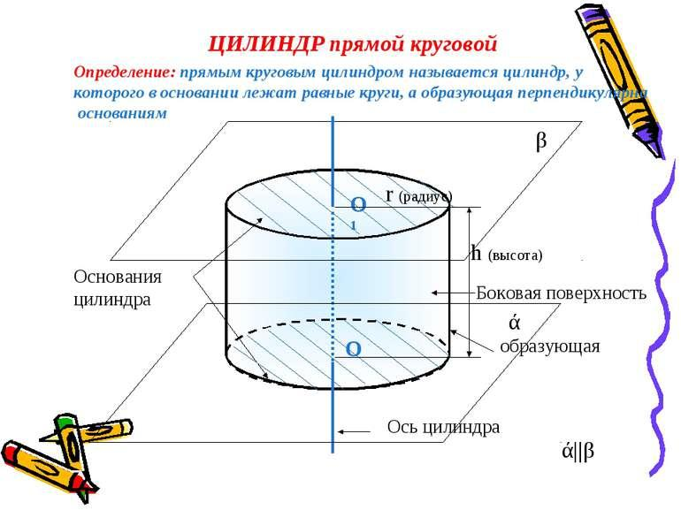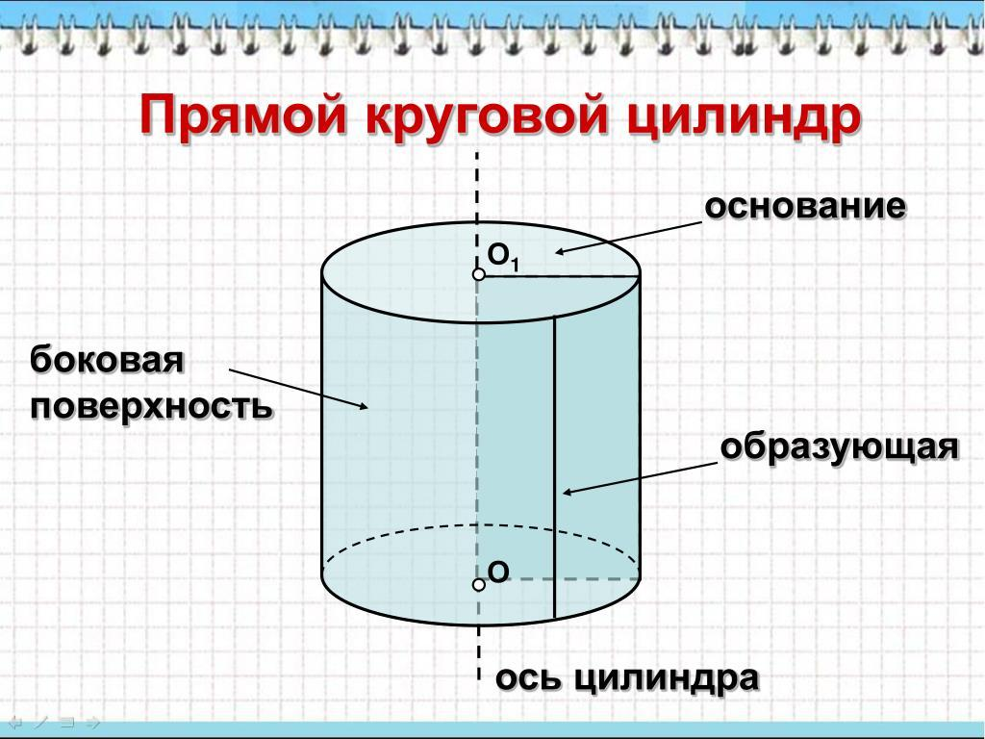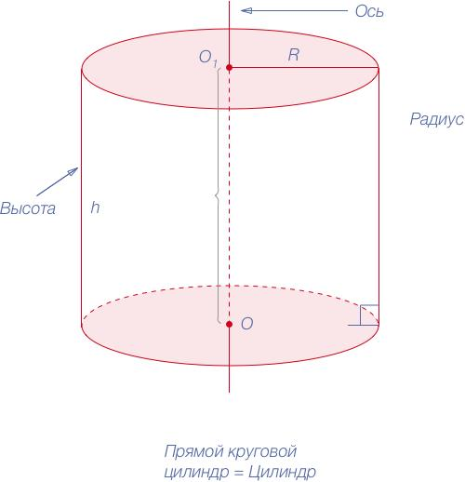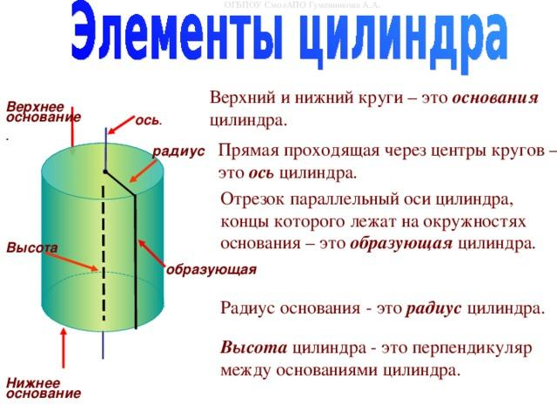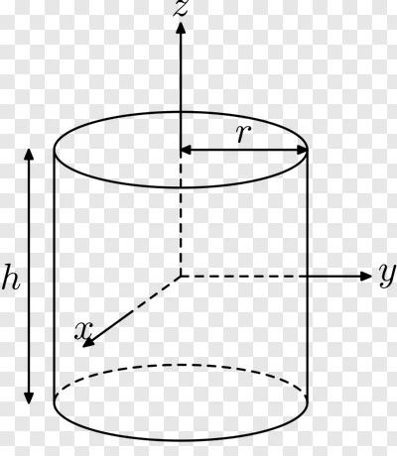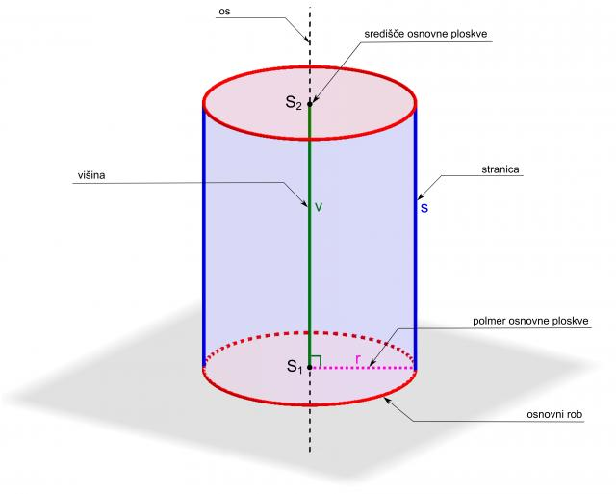

Definition
# Source: AI Source: Provided by: [Data Path: Persons Table -> ID Column: 1, Name_En Column: Motasem Essam] -> From: [ChatGPT] on [7/25/2026]
The axis of a right circular cylinder is the straight line passing through the centers of its two circular bases. It is perpendicular to the planes of both bases.
Because the cylinder is a right circular cylinder, its axis meets the base planes at right angles and passes through the center of each circular base.
- Axis: The central straight line of the cylinder.
- Direction: Perpendicular to the base planes.
- Position: Passes through both base centers.
- Axis length: Equal to the perpendicular height of the cylinder.
- Common notation: Often represented by a line segment joining the base centers, or by a line through the cylinder's central axis.

Simple Definition
# Source: AI Source: Provided by: [Data Path: Persons Table -> ID Column: 1, Name_En Column: Motasem Essam] -> From: [ChatGPT] on [7/25/2026]
The axis of a right circular cylinder is the straight line through the centers of its top and bottom circular bases, at a ${90}^{∘}$ angle to the bases.

Geometric Representation
# Source: AI Source: Provided by: [Data Path: Persons Table -> ID Column: 1, Name_En Column: Motasem Essam] -> From: [ChatGPT] on [7/25/2026]
Let $O_{1}$ and $O_{2}$ be the centers of the lower and upper circular bases.
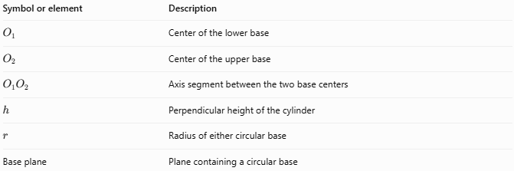
Symbol or element | Description
$$O_{1}$$ | Center of the lower base
$$O_{2}$$ | Center of the upper base
$$O_{1}O_{2}$$ | Axis segment between the two base centers
$$h$$ | Perpendicular height of the cylinder
$$r$$ | Radius of either circular base
Base plane | Plane containing a circular base
For a right circular cylinder, the axis segment $O_{1}O_{2}$ is perpendicular to both base planes.

Main Characteristics of the Axis
# Source: AI Source: Provided by: [Data Path: Persons Table -> ID Column: 1, Name_En Column: Motasem Essam] -> From: [ChatGPT] on [7/25/2026]
- Passes through both base centers: The axis joins the centers of the two circular bases.
- Perpendicular to the bases: It forms a ${90}^{∘}$ angle with each base plane.
- Defines the cylinder's direction: It establishes the central direction along which the cylinder extends.
- Equal to the height: The distance between the base centers equals the perpendicular height.
- Distinct from the lateral edges: The axis lies inside the cylinder, while the lateral edges lie on its curved surface.
- Rotational symmetry: The cylinder's shape remains unchanged when rotated about its axis.

Mathematical Properties and Formulas

Axis length and height
# Source: AI Source: Provided by: [Data Path: Persons Table -> ID Column: 1, Name_En Column: Motasem Essam] -> From: [ChatGPT] on [7/25/2026]
For a right circular cylinder:
$$\boxed{O_{1}O_{2}=h}$$
where $O_{1}O_{2}$ is the distance between the base centers and $h$ is the cylinder's height.

Axis perpendicularity
# Source: AI Source: Provided by: [Data Path: Persons Table -> ID Column: 1, Name_En Column: Motasem Essam] -> From: [ChatGPT] on [7/25/2026]
If $a$ is a direction vector for the axis and $n$ is a normal vector to a base plane, then:
$$\boxed{a∥n}$$
The axis is parallel to the base plane's normal vector, which means it is perpendicular to the plane.

Axis in three-dimensional coordinates
# Source: AI Source: Provided by: [Data Path: Persons Table -> ID Column: 1, Name_En Column: Motasem Essam] -> From: [ChatGPT] on [7/25/2026]
For a right circular cylinder whose axis is parallel to the $z$-axis, the base centers may be written as:
$$O_{1}=(a,b,z_{1}), O_{2}=(a,b,z_{2})$$
The axis has constant $x$- and $y$-coordinates:
$$\boxed{x=a, y=b}$$
Its length is:
$$\boxed{h=|z_{2}-z_{1}|}$$
For a cylinder centered on the $z$-axis, $a=b=0$, so its axis is $x=0, y=0$.

Worked Examples

Example 1 — Finding the axis length
# Source: AI Source: Provided by: [Data Path: Persons Table -> ID Column: 1, Name_En Column: Motasem Essam] -> From: [ChatGPT] on [7/25/2026]
A right circular cylinder has a height of $12 cm$. Find the distance between the centers of its circular bases.
Solution:
The axis length equals the height:
$$O_{1}O_{2}=h$$
$$\boxed{O_{1}O_{2}=12 cm}$$

Example 2 — Identifying the axis direction
# Source: AI Source: Provided by: [Data Path: Persons Table -> ID Column: 1, Name_En Column: Motasem Essam] -> From: [ChatGPT] on [7/25/2026]
A right circular cylinder has horizontal circular bases. What is the direction of its axis?
Solution:
The axis is perpendicular to the horizontal base planes. Therefore, it is vertical.

Example 3 — Finding the axis length from coordinates
# Source: AI Source: Provided by: [Data Path: Persons Table -> ID Column: 1, Name_En Column: Motasem Essam] -> From: [ChatGPT] on [7/25/2026]
The centers of the bases are $O_{1}=(2,3,1)$ and $O_{2}=(2,3,9)$. Find the axis length.
Solution:
The centers have identical $x$- and $y$-coordinates, so the axis is parallel to the $z$-axis.
$$O_{1}O_{2}=|9-1|$$
$$\boxed{O_{1}O_{2}=8 units}$$

Comparison with Related Axes
# Source: AI Source: Provided by: [Data Path: Persons Table -> ID Column: 1, Name_En Column: Motasem Essam] -> From: [ChatGPT] on [7/25/2026]
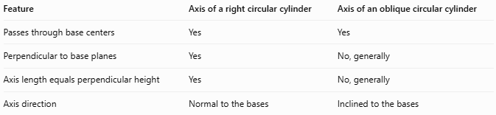
Feature | Axis of a right circular cylinder | Axis of an oblique circular cylinder
Passes through base centers | Yes | Yes
Perpendicular to base planes | Yes | No, generally
Axis length equals perpendicular height | Yes | No, generally
Axis direction | Normal to the bases | Inclined to the bases
Important distinction: Both right and oblique circular cylinders have an axis passing through the centers of their circular bases. What distinguishes the right circular cylinder is that its axis is perpendicular to the base planes.

Applications
# Source: AI Source: Provided by: [Data Path: Persons Table -> ID Column: 1, Name_En Column: Motasem Essam] -> From: [ChatGPT] on [7/25/2026]
The axis of a right circular cylinder is useful for:
- Defining the central direction of pipes, shafts, and cylindrical rods.
- Determining the height and orientation of cylindrical objects.
- Describing rotational symmetry in geometry.
- Establishing coordinate systems for three-dimensional calculations.
- Designing cylindrical mechanical components and structures.

Key Points
# Source: AI Source: Provided by: [Data Path: Persons Table -> ID Column: 1, Name_En Column: Motasem Essam] -> From: [ChatGPT] on [7/25/2026]
- The axis is the line passing through the centers of both circular bases.
- It is perpendicular to the base planes.
- The axis length equals the cylinder's height.
- It is an internal central line, not a visible lateral edge.
- Rotation about the axis leaves the cylinder's shape unchanged.
- An oblique cylinder's axis also passes through the base centers, but is generally inclined to the base planes.

Conclusion
# Source: AI Source: Provided by: [Data Path: Persons Table -> ID Column: 1, Name_En Column: Motasem Essam] -> From: [ChatGPT] on [7/25/2026]
The axis of a right circular cylinder is its central line, passing through the centers of the two circular bases and perpendicular to both base planes. Its length equals the cylinder's height, and it defines the cylinder's central direction and rotational symmetry.

